This Document explains the adding patients to Groups by Health Assistant

Note: Posts and comments are visible to Group Members

Login to Safe Hands Application as Health Assistant



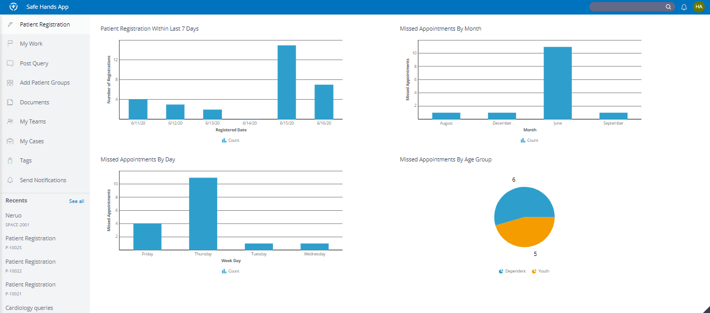

To Add Patient Groups Health Assistant Clicks on Add Patient Groups

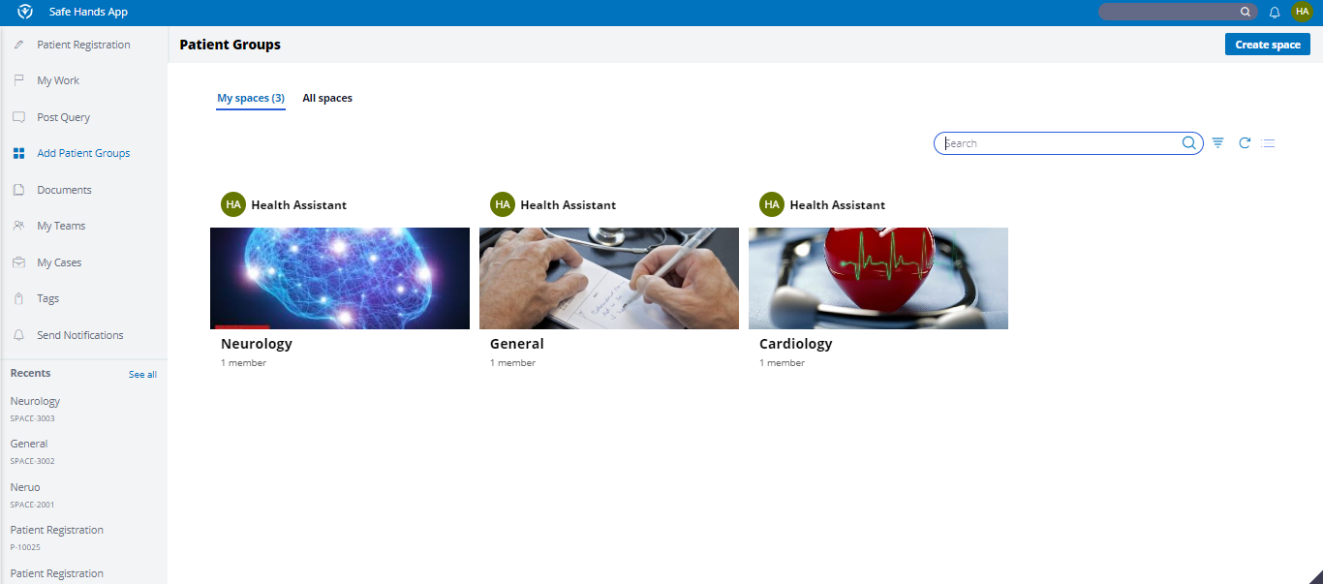

Adding Patient to General Group

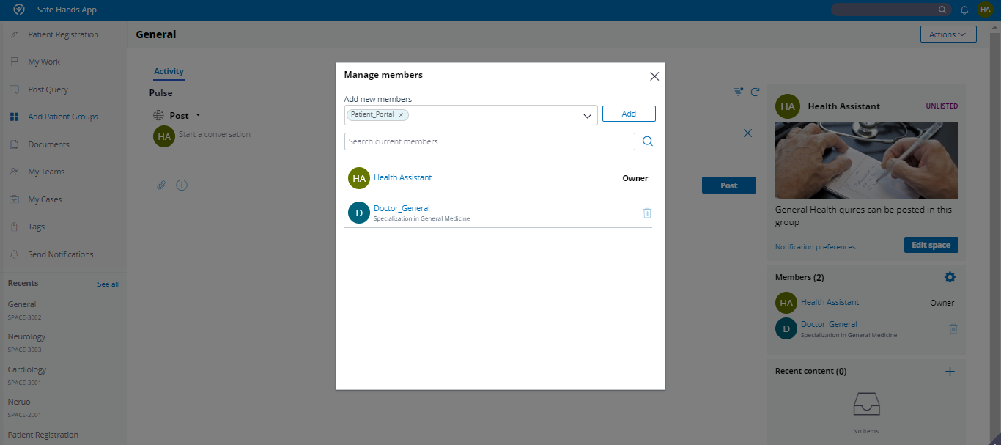

Login as Patient



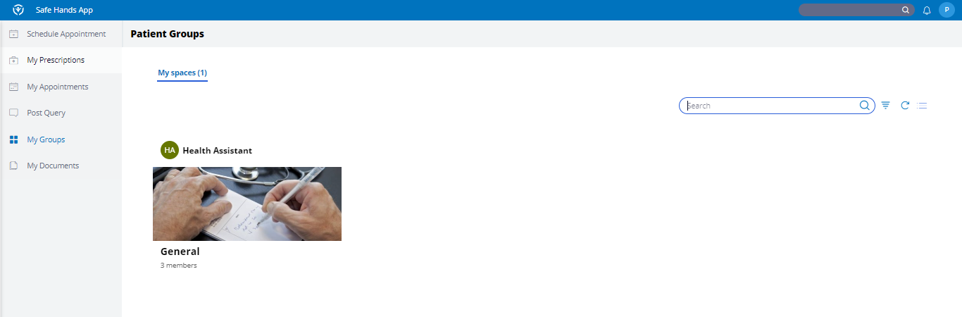

Patient clicks Groups and Post the Queries in the Group and reply from others patients in the group/From Doctors

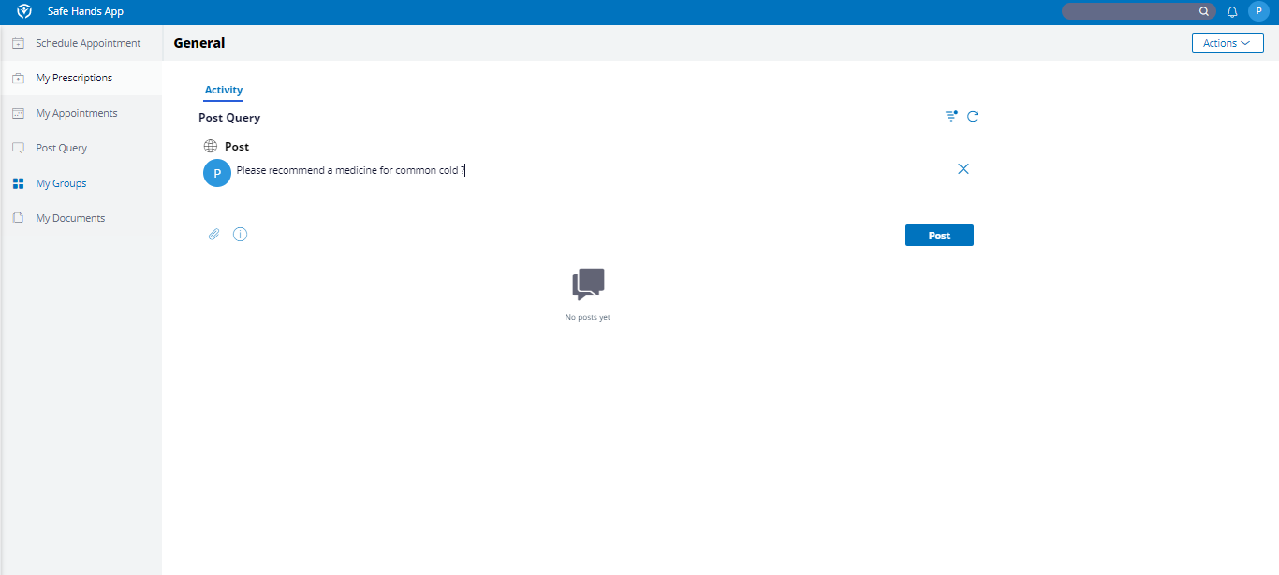

Question is posted by Patient

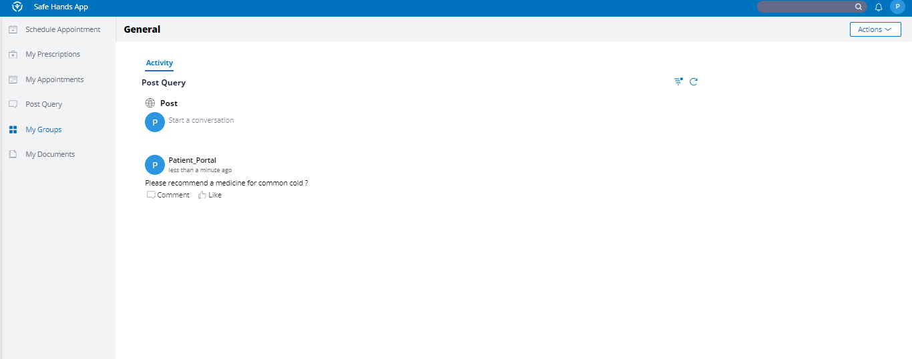

Login as Doctor to Ans the Patient Post.



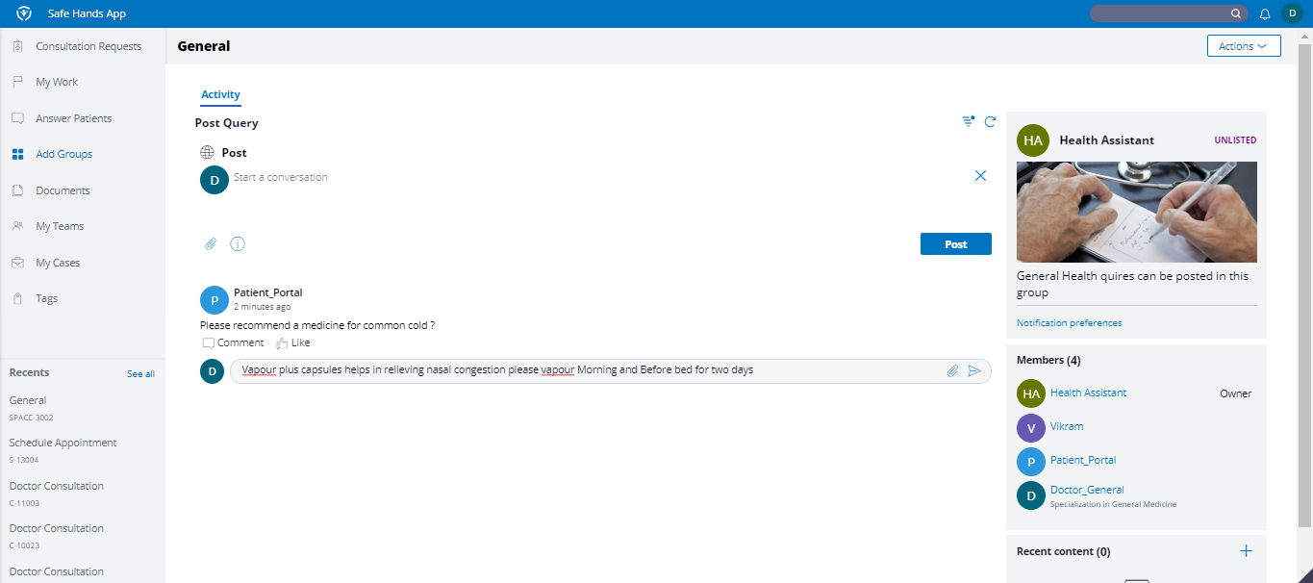

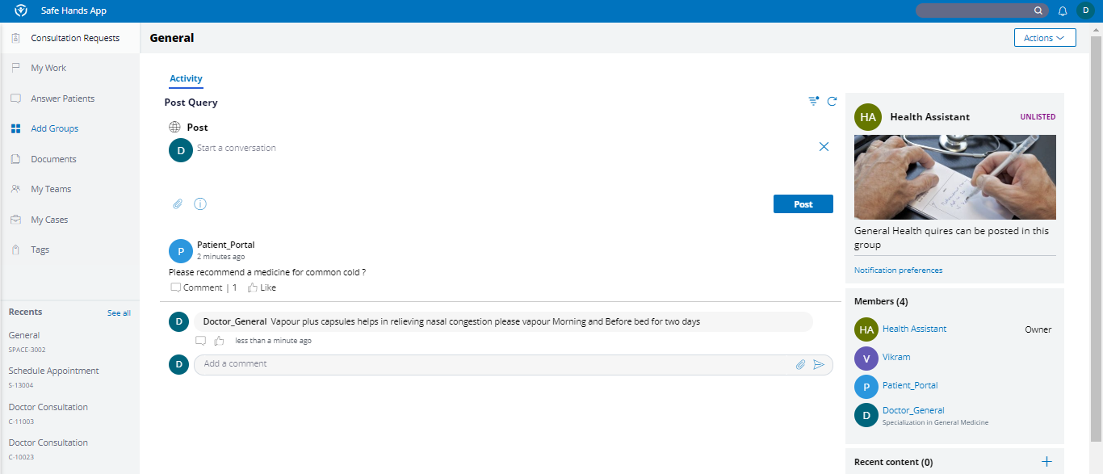

Login as Patient and check the comments on the Post



